./



|  |  |  |  |  |  |
| --- | --- | --- | --- | --- | --- |
| **Ver. Rel. No.** | **Release Date** | **Prepared. By** | **Reviewed By** | **Approved By** | **Remarks/Revision Details** |
|  | 08-03-2021 | Ujjawal Kumar 99003745 |  |  |  |
|  |  |  |  |  |  |
|  |  |  |  |  |  |
|  |  |  |  |  |  |
|  |  |  |  |  |  |

**Document History**

# 

**Contents**

**Activity 1** – 3

**Activity 2** – 4

**Activity 3** – 4

**Activity 4** – 5

**Activity 5** -- 5

GMC SIERRA SUNROOF CONTROL

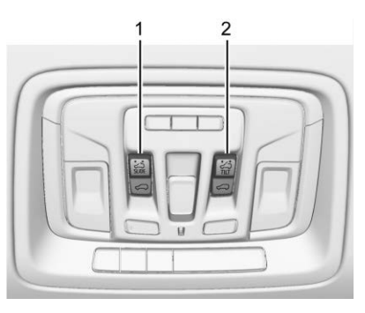

The sunroof operates when the ignition is on or in ACC/ ACCESSORY, or when Retained Accessory Power (RAP) is active.

**Slide Switch to Open:**

1: To express-open the sunroof, fully press and release (1).

2: Press and release (1) again to stop the movement.

**Slide Switch to Close:**

1: To express-close the sunroof, fully press and release K (1).

2: Press and release K (1) again to stop the movement.

**Tilt Switch Vent:**

**1:** From the closed position, press (2) to vent the sunroof.

2: Press K (2) to close the vent.

When the sunroof is opened, an air deflector will automatically raise. The air deflector will retract when the sunroof is closed.

The sunroof also has a sunshade, which can be pulled forward to block sun rays. The sunshade must be opened and closed manually.

**Automatic Reversal System**

The sunroof has an automatic reversal system that is only active when the sunroof is operated in express-close mode. If an object is in the path while express-closing, the reversal system will detect an object, stop, and open the sunroof slightly. If frost or other conditions prevent closing, override the feature by closing the sunroof in manual mode. To stop movement, release K (1). Dirt and debris may collect on the sunroof seal or in the track. This could cause an issue with sunroof operation or noise. It could also plug the water drainage system. Periodically open the sunroof and remove any obstacles or loose debris. Wipe the sunroof seal and roof sealing area using a clean cloth, mild soap, and water. Do not remove grease from the sunroof tracks. If water is seen dripping into the water drainage system, this is normal.

**Research**

1. Two set of Switch (each for sliding/Tilting)
2. Sensor (for automatic reversal system when object is in between panel and car body)
3. Motor

**Requirements:**

1. High Level Requirements:

* Opening/Closing Sunroof
* Tilting Sunroof

1. Low Level Requirements:

* Switch Control
* Operating motor used for sunroof panels

**INPUT:**

1. Switches

main image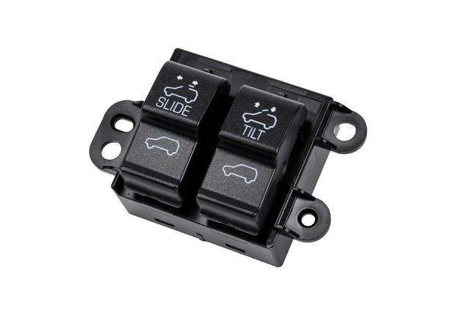

1. **Sensor:**
2. Honeywell’s Linear Hall-effect Sensor ICs: SS490 Series

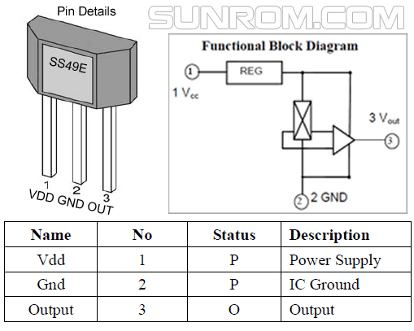

Fig: Honeywell’s Linear Hall-effect Sensor pins

|  |  |  |  |
| --- | --- | --- | --- |
| **Characteristic** | **Min.** | **Max.** | **Unit** |
| Supply current | - | 8.7 | mA |
| Output Current | 0.6 | 1.5 | mA |
| Supply voltage | -0.5 | 11 | V |
| Output voltage | -0.5 | 11 | V |
| Operating Temp | -40 | 150 | C |
| Linearity | 0 | -1.5 | % of span |
| Sensitivity | 4.6 | 5.4 | mV/Gauss |

Table: Honeywell’s Linear Hall-effect Sensor ICs Specification

**Characteristics (V/Gauss)**

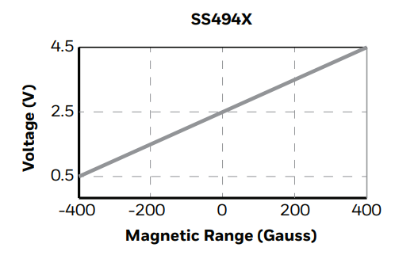

Fig: (V/Gauss) Characteristics

Application:

* Basic current sensing for motor load monitoring, detection
* Handlebar/throttle position sensing in e-bikes and scooters
* Current sensing in appliances
* Speed adjustment trigger in tools and appliances

1. DRV5055XX Ratio Metric Linear Hall Effect Sensor

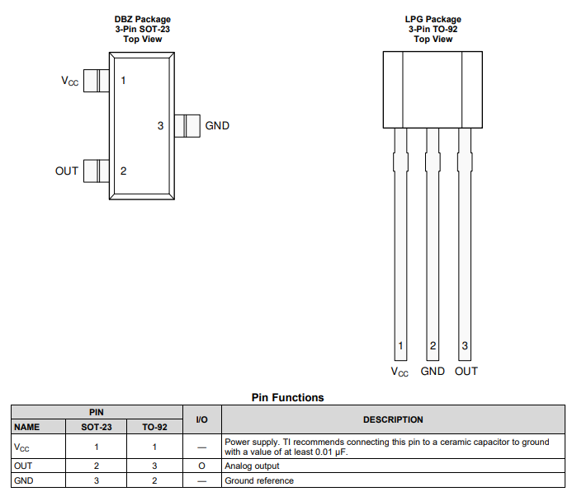

Fig: Pin Configuration

|  |  |  |  |
| --- | --- | --- | --- |
| Parameter | MIN | MAX | UNIT |
| Supply Voltage | 3 | 5.5 | V |
| Supply Current | - | 10 | mA |
| Output Current | -1 | 1 | mA |
| Operating Temperature | -40 | 125 | C |
| Sensitivity | 95 | 100 | mV/mT |
| Linear Magnetic Sensing | ±21 | ±169 | mT |

Table: DRV5055 Ratio Metric Linear Hall Effect Sensor Specification

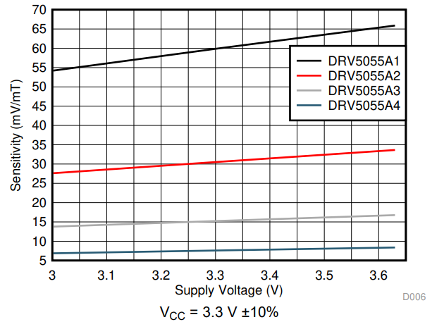

Fig: Sensitivity vs Supply Voltage

Application:

• Precise Position Sensing

• Industrial Automation and Robotics

• Gamepads, Pedals, Keyboards, Triggers

• Current Sensing

1. Linear Output Magnetic Field Sensor AD22151:

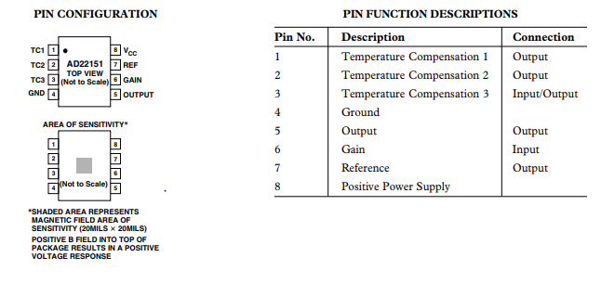

Fig: Pin Configuration

|  |  |  |  |
| --- | --- | --- | --- |
| Parameter | MIN | MAX | UNIT |
| Supply Voltage | 4.5 | 6.0 | V |
| Supply Current | - | 10 | mA |
| Operating Temperature | -40 | +150 | C |
| Nonlinearity |  | 0.1 | %FS |
|  |  |  |  |
|  |  |  |  |

Table: Sensor Specification

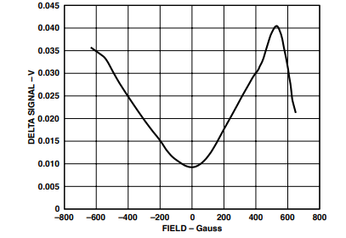

Fig: Characteristics

Application:

* Anti-Pinch control
* Throttle Position Sensing
* Pedal Position Sensing
* Suspension Position Sensing
* Valve Position Sensing

**OUTPUT:**

1. **Motor output:**

For running the motor first, we need half bridge for running the sunroof motor.

Here I’m using **NovalithIC™ BTN8982TA** Integrated high current half-bridge motor drivers.

BTN8962TA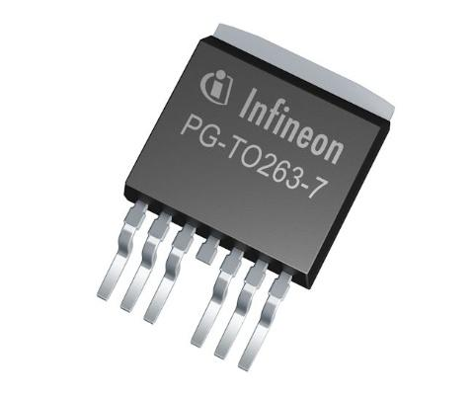

Fig: NovalithIC™ BTN8982TA

|  |  |  |  |
| --- | --- | --- | --- |
| Parameter | Min. | Max. | Unit |
| Input Voltage | -0.3 | 5.3 | V |
| Output Voltage | -0.3 | 40 | V |
| Current | - | 3.3 | mA |
| Junction Temperature | -40 | 150 | C |

Table: Motor Driver Specification

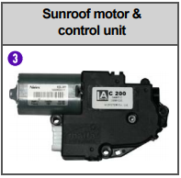

Fig: sunroof motor control unit

|  |  |  |  |
| --- | --- | --- | --- |
| Parameter | Min | Max | Unit |
| Operating voltage | 9 | 16 | V |
| Operating current | - | 6 | A |
| At no load | - | 3 | A |
| Roof motor operating speed |  | 1.4 ± 0.5 sec./100 mm |  |

Table: Motor specification

SWOT Analysis

|  |  |
| --- | --- |
| Strength   1. Tilting Roof 2. Anti Pinch Panel | Weakness |
| Opportunities | Threats |

Final Evolution:

|  |  |
| --- | --- |
| Before   1. No sensor used 2. Roof control is on Knob system 3. No information of motor we used | After   1. Use of hall sensor for object detection 2. Roof control is on Dual switch system 3. Research on motor is done |